Group id : A6

Project Name : Stock Candle

**Assignment 10**

Title: Prepare Activity Model

Problem Statement: Identify Activity states and Action states. Draw Activity diagram

with Swim lanes using UML2.0 Notations for major Use Cases.

Theory :

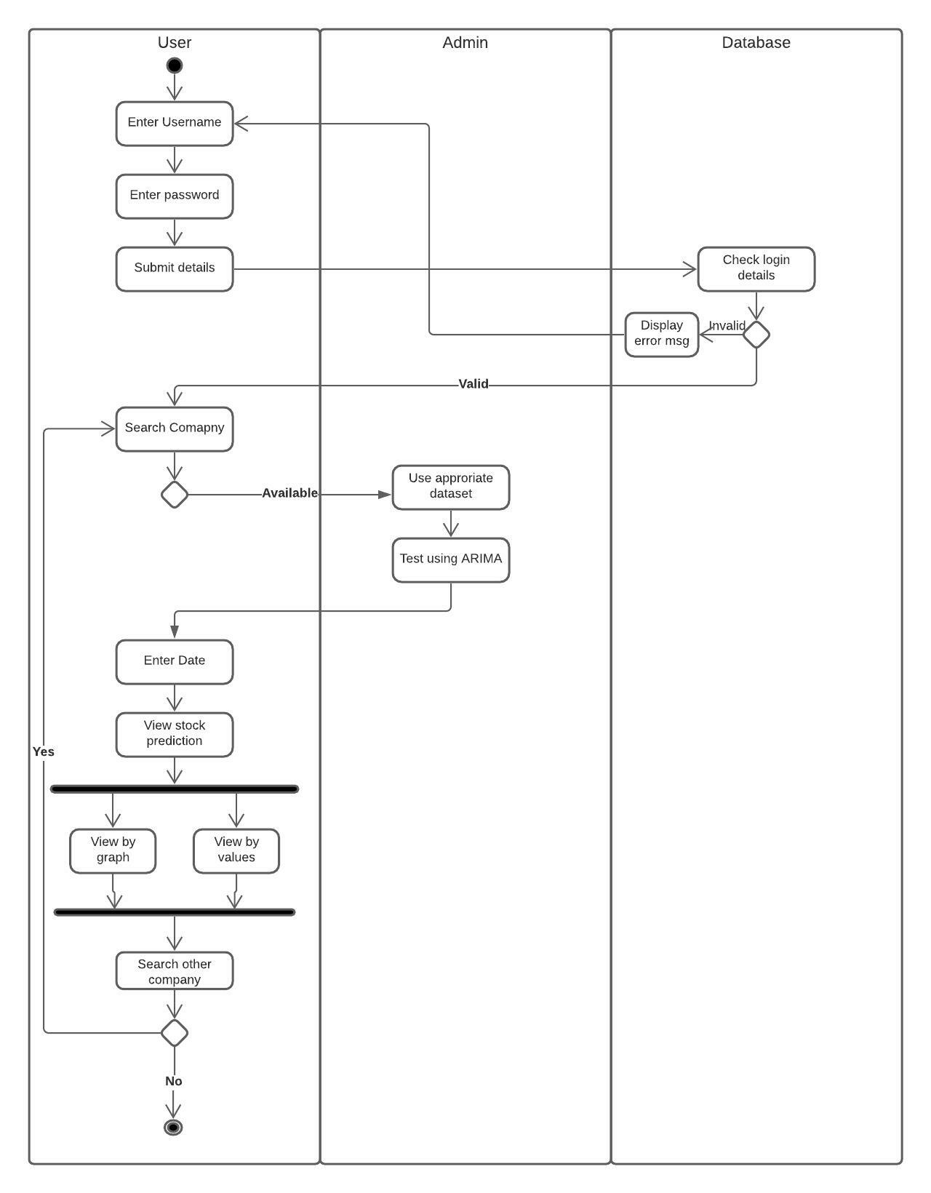

**Conclusion :** Thus, we have prepared uml activity diagram using advanced uml2 notations and lucid chart.